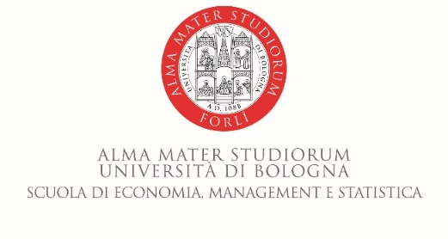

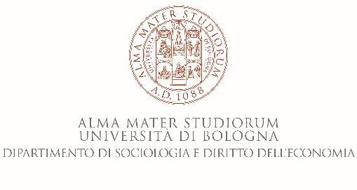

**Scuola di Economia, Management e Statistica**

**7 June 2018, Room 4** (ground level)

Piazzale della Vittoria 15 - Forlì

**Session 1: Room 4**

10.00-10.15 – Introduction Prof. Federica Farneti

10.15-13.00 – The influence of stakeholders on integrated reporting: a case study Prof. Charl de Villiers, Professor of Accounting, Graduate School of Management, The University of Auckland, New Zealand and Editor-in-Chief: Meditari Accountancy Research and Editor of the book Sustainability Accounting and Integrated Reporting

To book to take part at the seminar, plese send an email to: Federica.farneti@unibo.it

**Con il Patrocinio del Comune di Forlì**

**Con il Patrocinio del Comune di Forlì**

**University of Bologna, Italy**

**School of Economics, Management and Statistics – Forlì Campus**

**Piazzale della Vittoria, 15 – 47121 Forlì (FC), Italy**